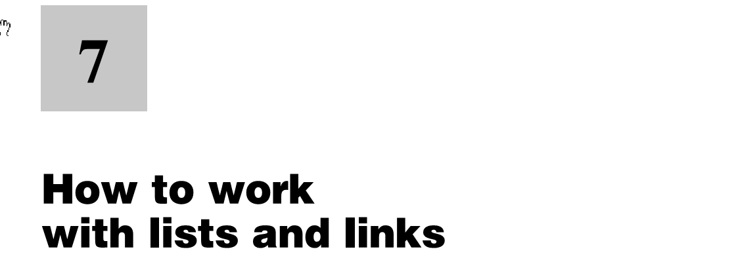

Creating Unordered Lists (Formatting Later)
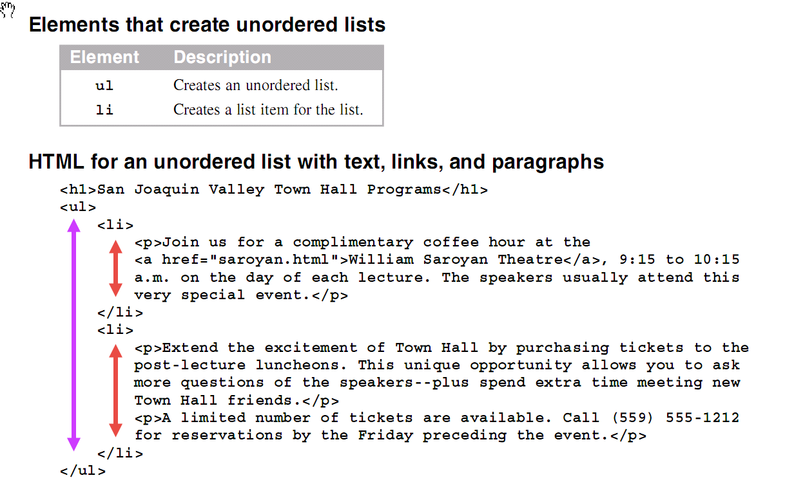
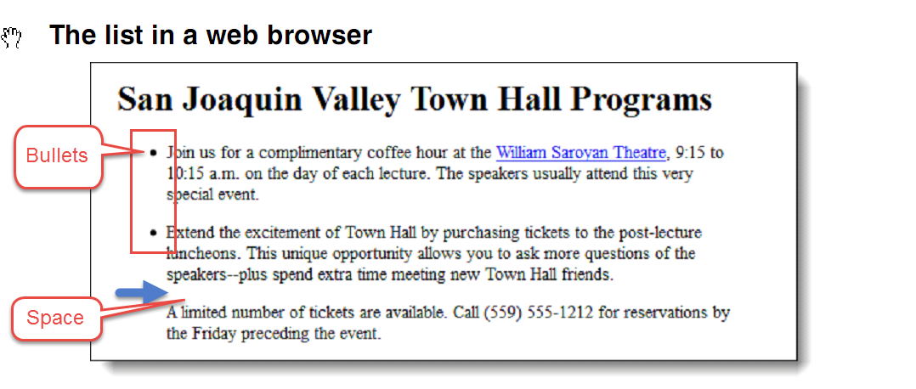

Coding Ordered Lists
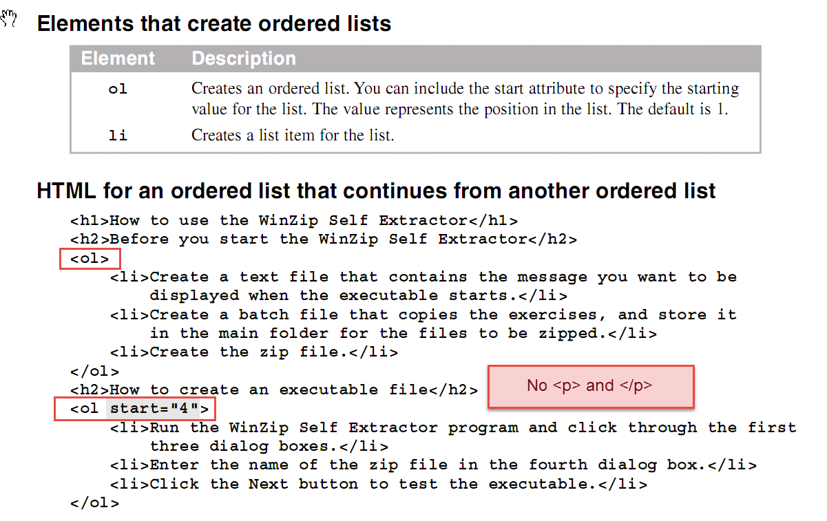
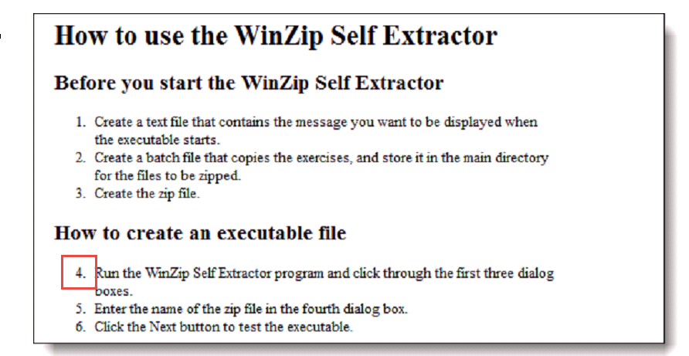

Coding Nested Lists
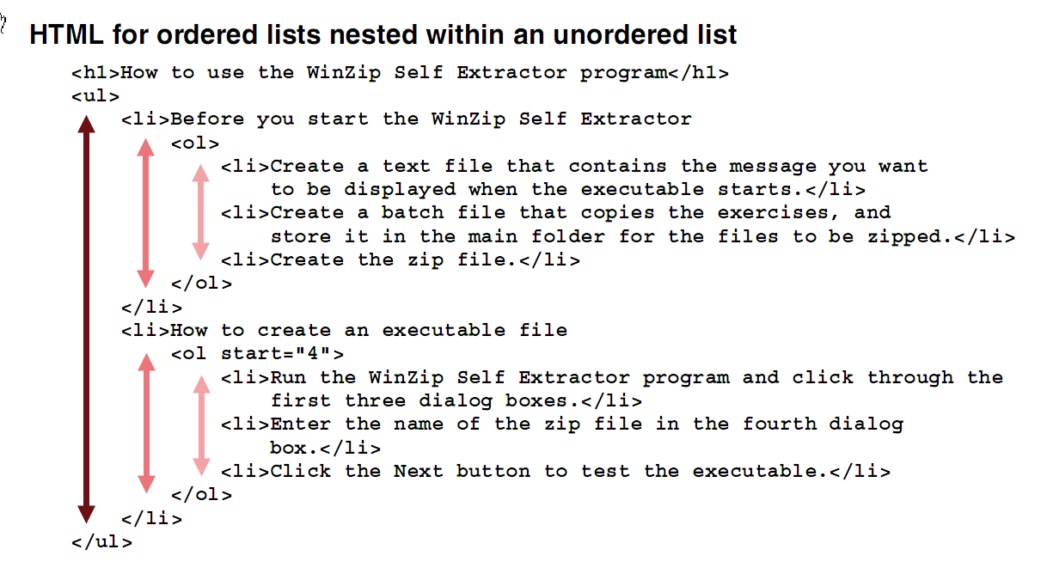
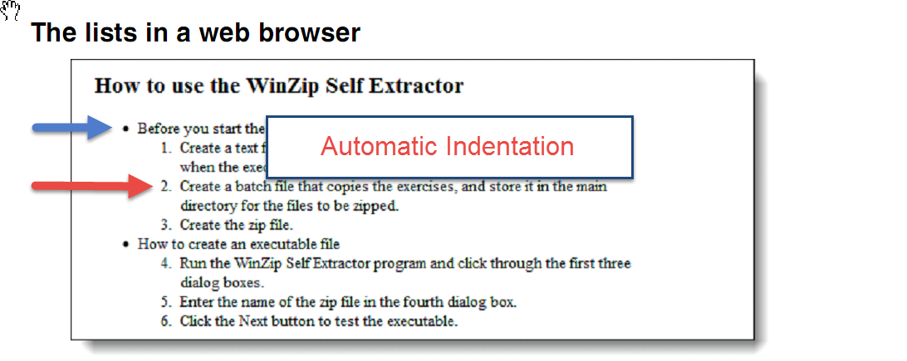

How to Code a Description List
We will not cover this, but it is cool.
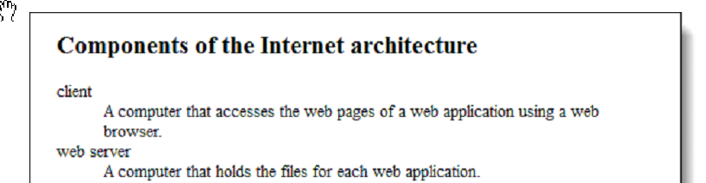

Formatting Lists

Changing Bullets in an Unordered List (Ignore material on creating new bullet images)
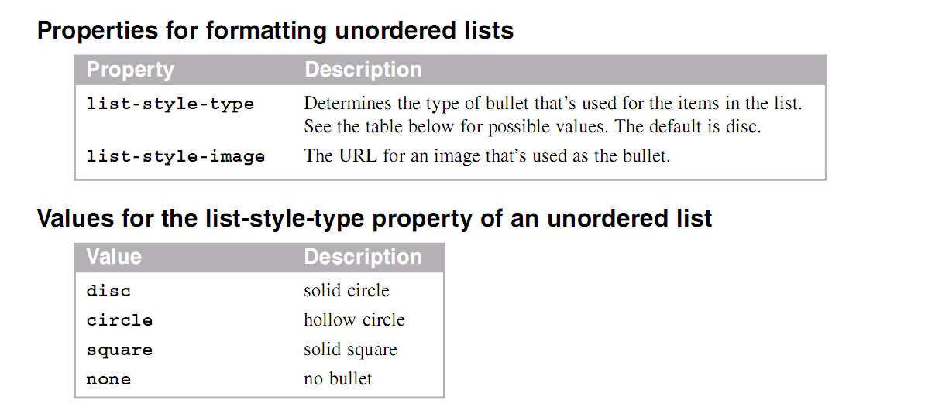
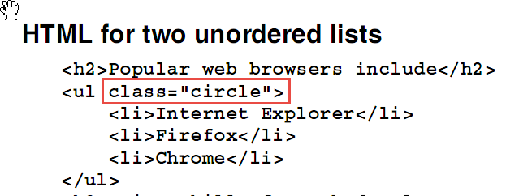
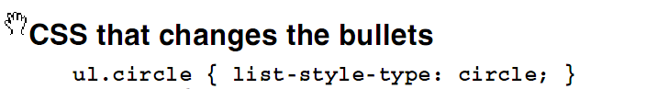

Changing the Numbering System for an Ordered List
Ignore this. Beyond this course but cool.

Changing the Alignment of List Items
Ignore this. Beyond this course but cool.

How to Code Links

<a>Text to be displayed (underlined by default)</a>

<a href=”File”>Text to be displayed (underlined by default)</a>

How to Link to another Page
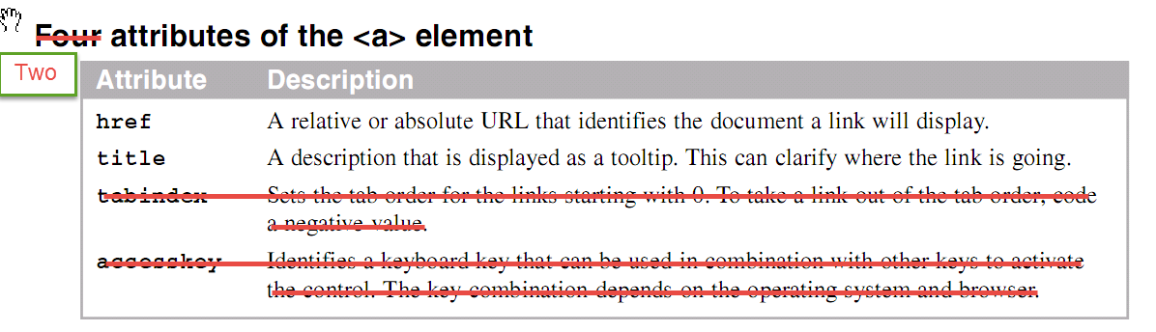
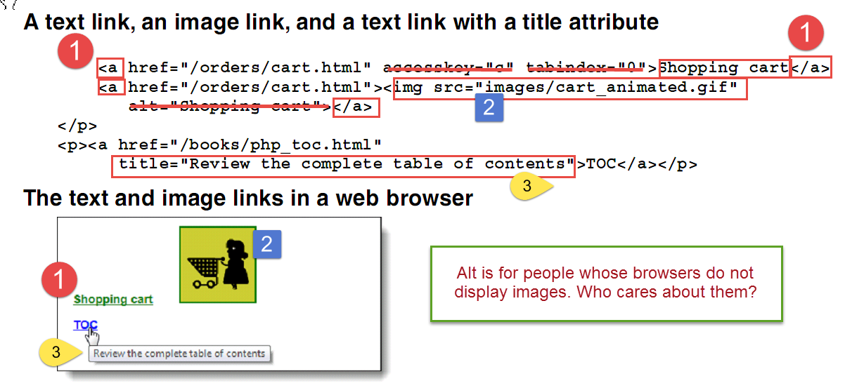

How to Format Links
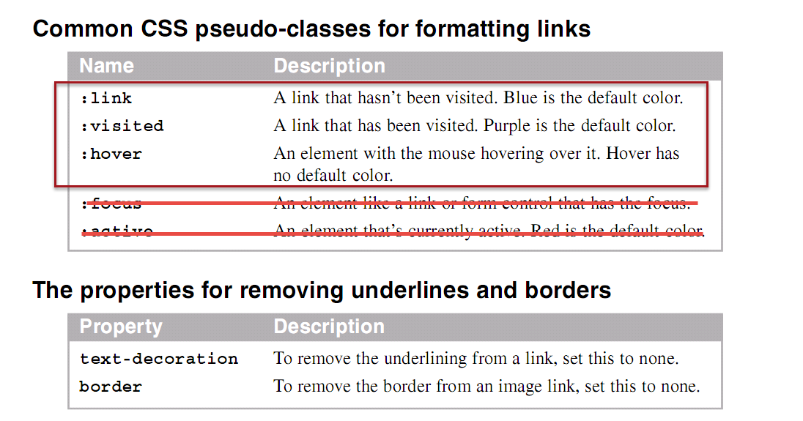
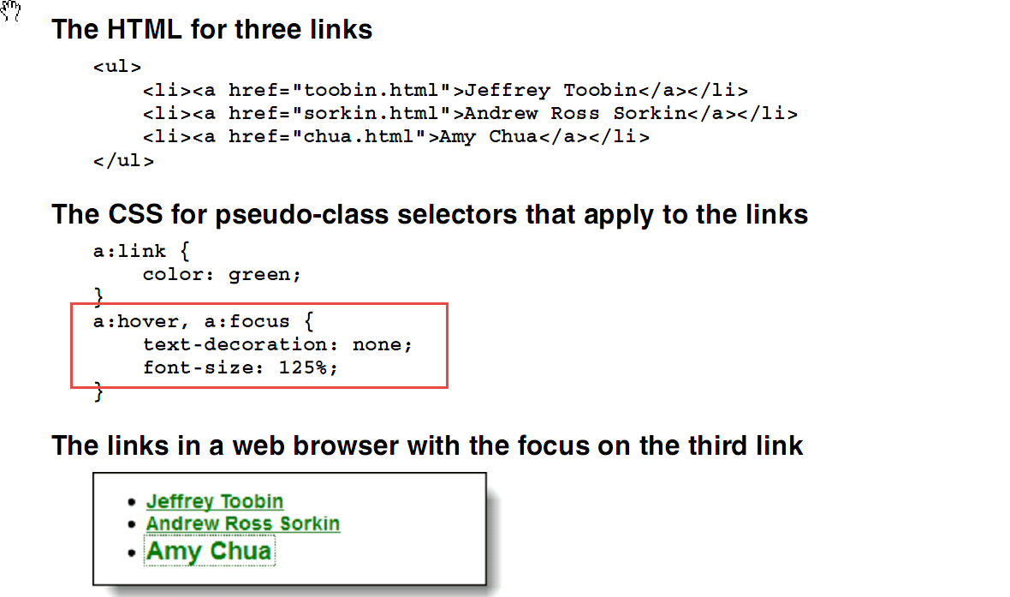

Opening a Link in a New Tab or Window
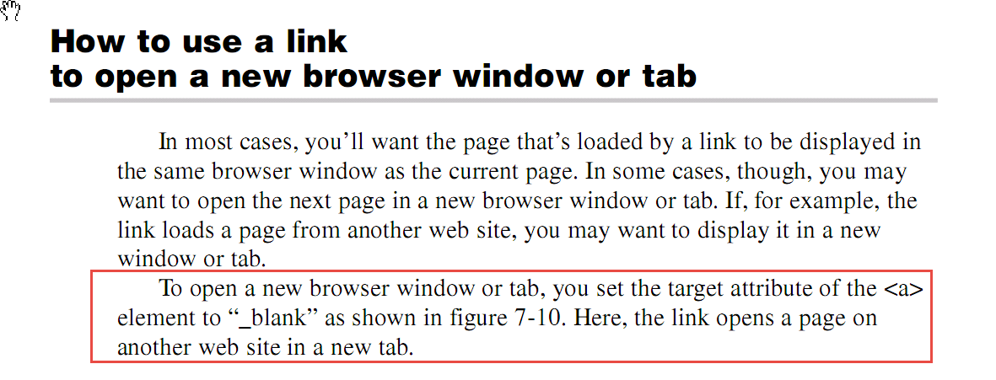
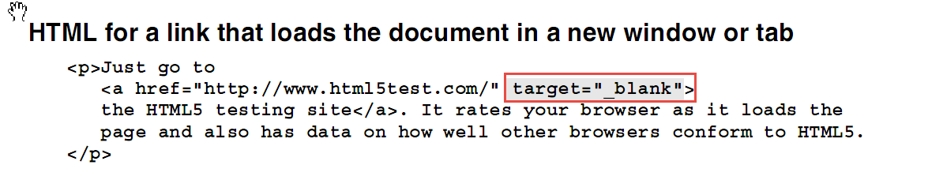

Linking to a Placeholder on the Same Page
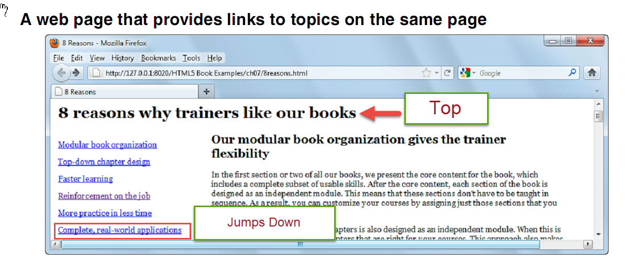
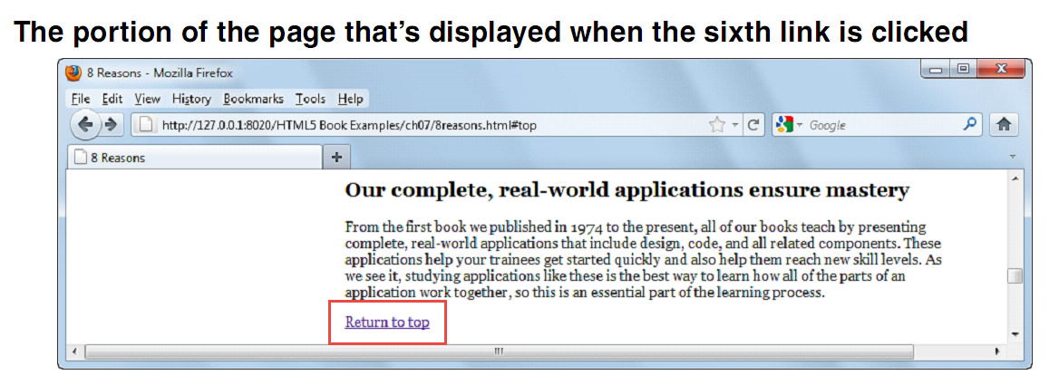
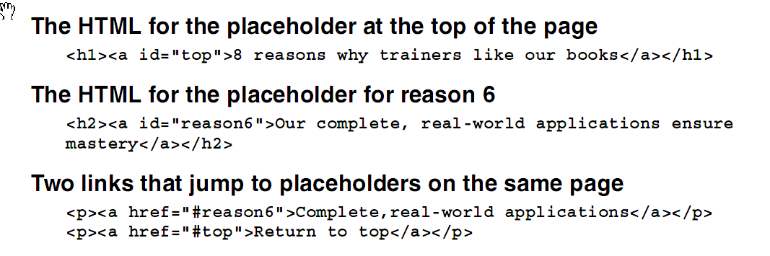

How to Link to a Media File
We will not cover this for now

How to Create Navigation Lists and Bars
Use an unordered list
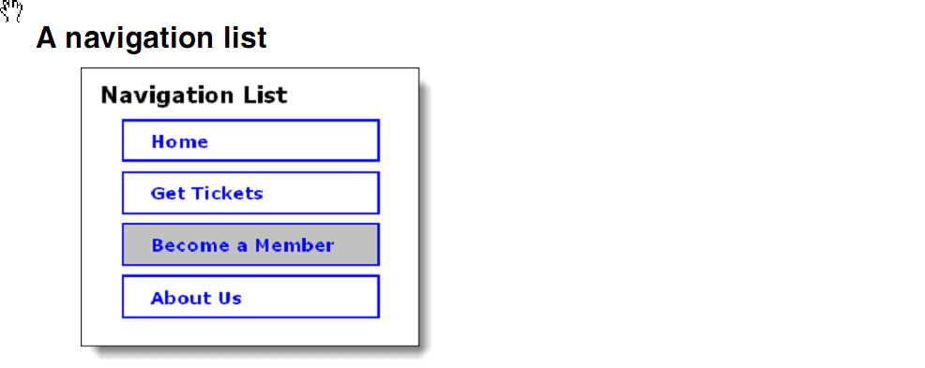
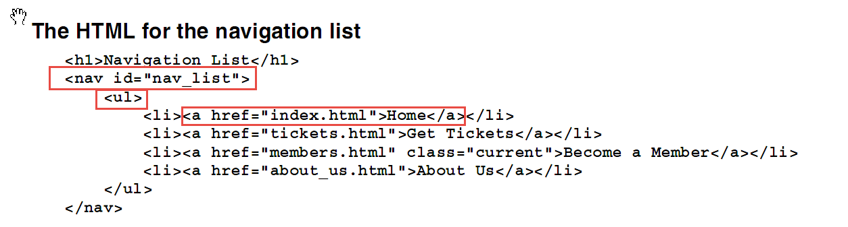
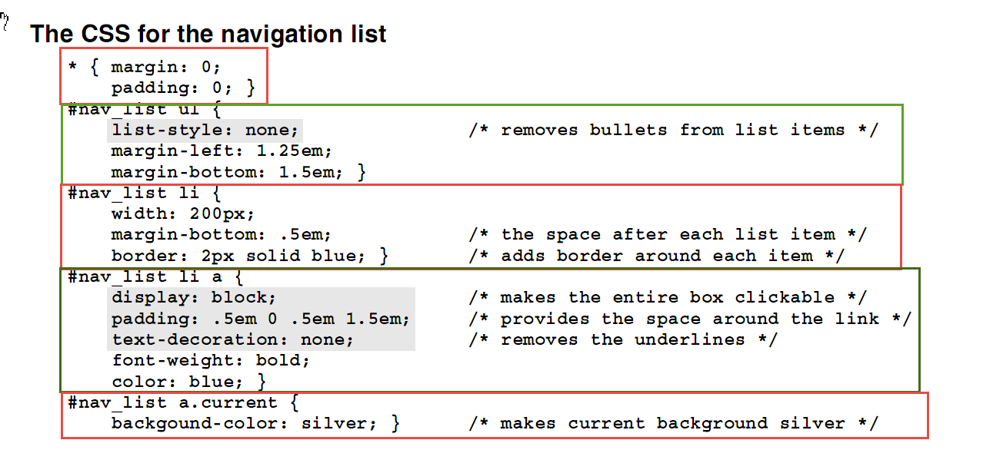

How to Create a Navigation Bar
